Tuan Pham

For each of the five random positions show:

* + The student id you are searching for
  + The hash generated that you are searching for
  + The found position in the second array
  + The student id, name, and original position in file

Lookup the 1st student (the hash key is also the position in the hash table). That’s mean the first student in the original file is stored in 25th element in the hash table. And this 25th element might content more than one students which will be solved in my Search() function.

Write/display the Hash Table to file “StudentHashTable.txt”

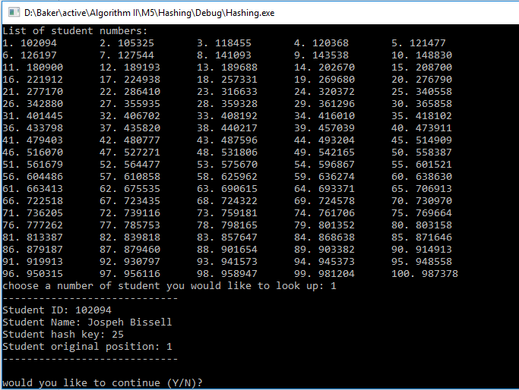

Lookup the 13th student

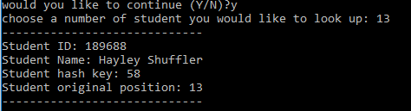

Lookup the 27th student

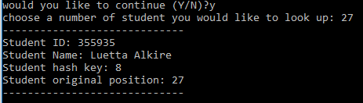

Go to Main.cpp -> uncomment line 67-69 to print the hash table to the console like this:

